Student Management ERP System



Project Team
Name | Role
Aanya Bhandari | Project Lead
Khushi Verma | Team Member
Ipshita Arora | Team Member
Nisha Tanwar | Team Member

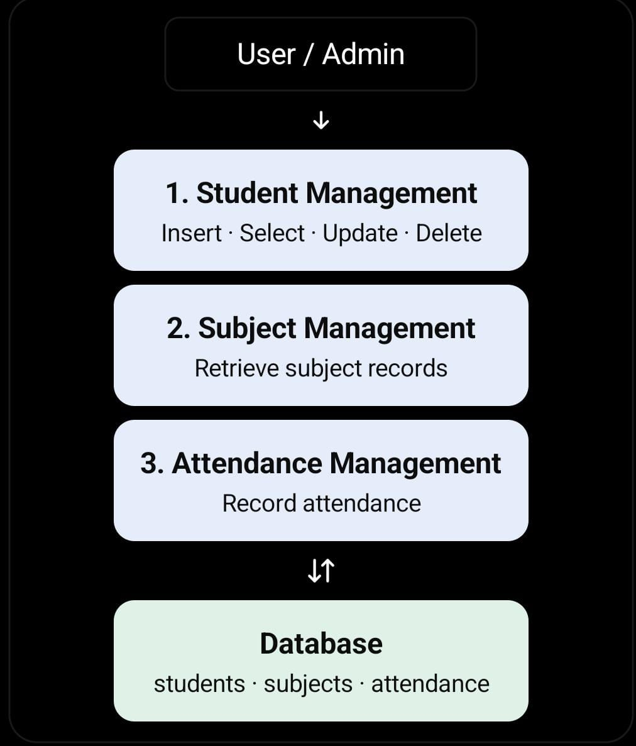

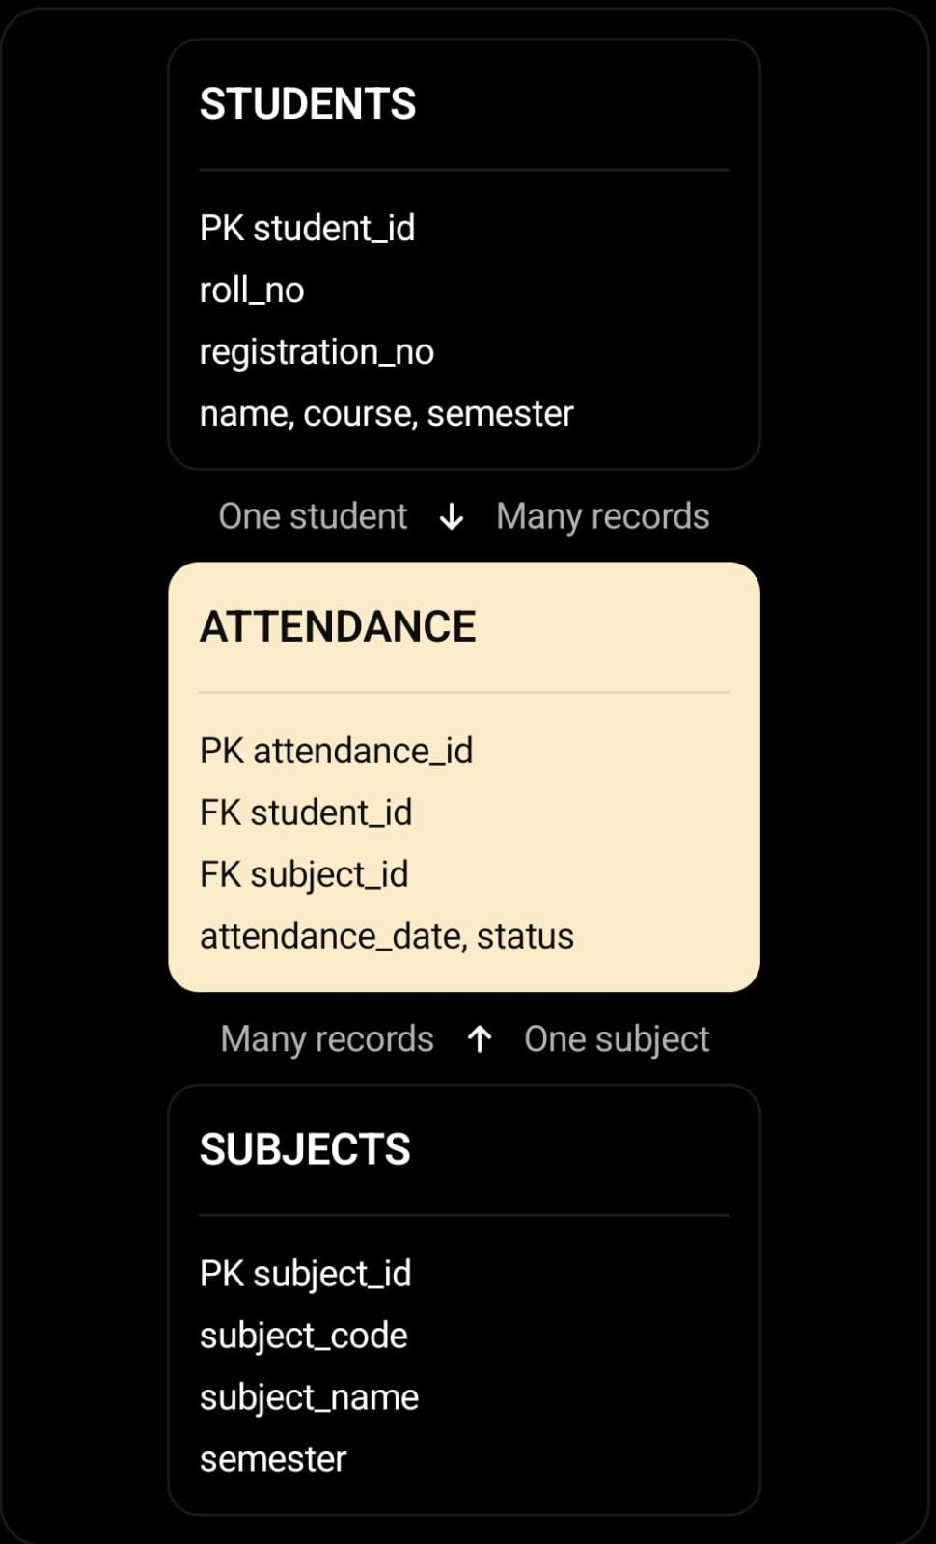

Project Description

Our project is a Student Management ERP System designed to make the management of student information easier, faster, and more organized. In colleges, a lot of student-related information such as roll numbers, registration numbers, personal details, course, semester, subjects, and attendance needs to be maintained regularly. Managing all this information manually can take a lot of time and can also lead to mistakes or loss of records.
To solve this problem, we have developed a simple ERP-based web application where student information can be stored and managed in one place. The system allows the user to add new student records, view existing records, search for a particular student, update information when required, and delete records that are no longer needed.
The project also includes a Subject Management section and an Attendance Management section. Subjects can be maintained according to the semester, while attendance can be recorded by selecting a student, subject, date, and attendance status. The different sections are connected through the database, which makes the system more organized and useful.
We have used HTML and CSS for designing the interface, PHP for the backend functionality, and MySQL/MariaDB for storing the data. XAMPP is used as the local server environment, and phpMyAdmin is used to manage the database.
The main purpose of this project is to understand how a database-driven application works in a real-world situation. Through this project, we have learned how frontend pages, backend programming, databases, and CRUD operations work together to create a complete management system.

STUDENTS | student_id | Stores student details
SUBJECTS | subject_id | Stores unique ID
ATTENDANCE | attendance_id | Marks attendance

Main Features
- Student registration and record management
- Add new student details
- View all student records
- Search students by name, roll number, registration number, or course
- Edit and update student information
- Delete student records
- Subject management
- Attendance management
- Database connectivity
- Simple and user-friendly interface
- CRUD operations using PHP and MySQL/MariaDB
- Related database tables using primary and foreign keys

Overall System Architecture
The Student Management ERP System follows a basic client-server architecture consisting of a frontend, backend, and database.
The frontend is developed using HTML and CSS. HTML defines the structure of the pages, forms, navigation links, and tables, while CSS controls their appearance and layout.
The backend is developed using PHP. It processes form submissions, handles requests, executes SQL queries, and retrieves information from the database. The db.php file contains the database connection settings and is included in the PHP pages that require database access.
MySQL/MariaDB is used to store student, subject, and attendance information. XAMPP provides the local environment required to run Apache and PHP and to access the database service. phpMyAdmin provides a graphical interface for creating tables, importing SQL files, and inspecting database records.
When the user opens the website, the browser sends a request to the local web server. Apache serves the request, PHP executes the relevant application code, and the application communicates with the database when necessary. The resulting page is then returned to the browser for display.
The overall architecture can be summarized as:
User → Web Browser → Apache/PHP → MySQL/MariaDB Database → PHP Response → Web Browser.

Technology Used
- Frontend: HTML, CSS
- Backend: PHP
- Database: MySQL/MariaDB
- Server: XAMPP (Apache)
- Database Management: phpMyAdmin
- Editor: Notepad

Conclusion
The system flowchart, Data Flow Diagrams, ER diagram, and database table structure together provide a clear understanding of the design and operation of the Student Management ERP System.
The flowchart explains the sequence of user activities, the DFD diagrams explain how information moves through the application, the ER diagram illustrates the relationships between database entities, and the database structure describes how information is organized and stored.
These diagrams support the documentation of the project and demonstrate the practical use of web development technologies, PHP-based processing, SQL queries, and relational database design in developing a student information management application.

